# Analysis and Experiments Conducted

A list of different analysis carried out and their screen shots are attached below.

1. Time of the day and accidents

This is a roll up operation over time hierarchy and total collisions happened for different time periods are shown below.

Total collisions happened in 2015

select Year, sum(count) as total_collisions from crashesClean where year=2015 group by year;



Collisions in each year

select Year, sum(count) as total_collisions from crashesClean where year>=2000 group by year;

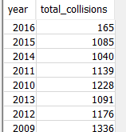

Total collisions after 2001

select sum(count) as total_collisions from crashesClean where year>=2001;



Accidents happened in morning and evening

select Year, sum(count) as total_collisions_evening from crashesClean where Hour>=18 group by year;

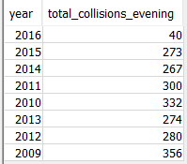

select Year, sum(count) as total_collisions_morning from crashesClean where year=2015 and Hour<6 group by year;

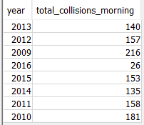

1. Impact of day of week on accidents : Is there a particular day the accidents happen?

select Dayweek,sum(count) as total_collisions from crashesClean group by Dayweek order by total_collisions;

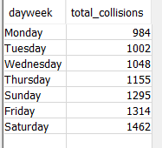

1. Analysis of accidents based on age : is youth drivers more reckless than others ?

select AgeofVictim,sum(count) as total_collisions from fatalitiesClean group by AgeofVictim order by total_collisions ;

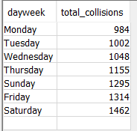

1. Age and gender a factor on number of accidents :

select AgeofVictim,gender,sum(count) as total_collisions from fatalitiesClean

group by AgeofVictim,gender order by total_collisions desc;

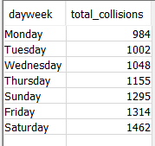

1. Is heavy vehicles causing more accidents than normal vehicles? Analysis on type of vehicle

select sum(count) as heavy_veh_accident from fatalitiesDist where Bus_Involvement= 'Yes'

or Rigid_Truck_Involvement= 'Yes' or Articulated_Truck_Involvement = 'Yes';



1. State a factor in number of accidents

Is there a particular state where the no of accidents are more frequent than others ? it is clear from the data that new south wales and QLD tops the chart.

select state,sum(count) as total_collision,year from fatalitiesDist group by year,state order by year asc ,total_collision desc;

